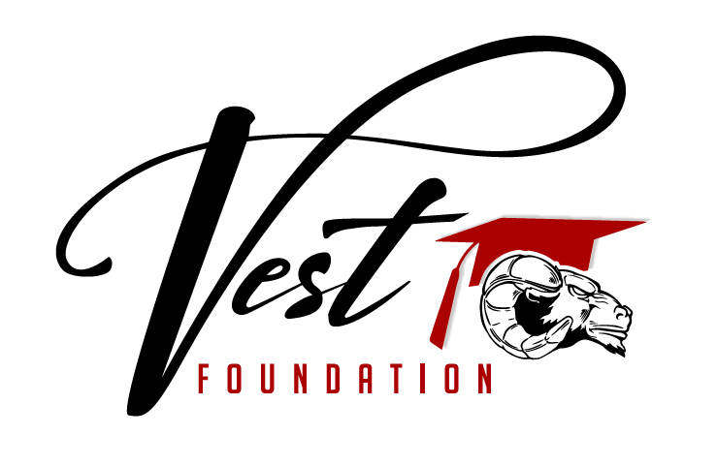

vestfoundationcv@gmail.com vestfoundation-cv.org
Scholarship Application Form

This application is for Senior CV students who will graduate this spring and go on to attend traditional and non-traditional education institutions. (2-year, 4-year, technical/vocational, specialized training)

Name:
Address:
Date of Birth:
Phone: ( ) -
Parent(s)/Guardian(s)/Grandparent(s):
Parent(s) Occupation(s):
Grade Point Average:
How did you hear about this scholarship?

The selection committee will not have access to this first page. Selection will be based upon your responses on the following pages. Any names will be blocked out as much as possible. Your identity will be revealed after the selection is made.
If you are selected as a recipient, the scholarship funds will be sent directly to the college you have chosen upon the start of the 2nd semester after proof of enrollment has been provided.

Scholarship applications are due April 30th, 2026 by 4:00p.m.
Submit to: CVHS Office or e-mail to vestfoundationcv@gmail.com
Applications that are late will not be collected or considered.

VEST FOUNDATION Scholarship Application

Please check which scholarship(s) you are applying for:
Bud Springer Award______ Pfefferkorn Award________ VEST Foundation Award________

GPA:_________
School/Training you plan to attend:
Major/Course of study:
How long have you attended Clearwater Valley Schools?

QUESTIONAIRE
On a separate sheet of paper, please type or print responses to the following questions:

- Write a short, two paragraph autobiography about yourself. Include your interests and what you like to do with your free time.

- What activities have you participated in during high school (includes outside of school opportunities)?

- What leadership roles, if any, have you had during high school (includes outside of school opportunities)?

- What honors and/or awards have you received (includes outside of school opportunities)?

- Tell us about your future goals and what motivates you to further your education.

- When you finish college/training, are you planning on coming back to this area and what do you see yourself doing in 20 years?

