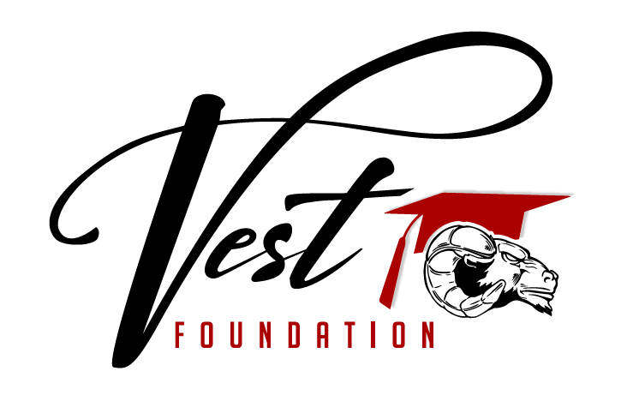
Name of Applicant: _______________________________
Group/Class/Project Name: ________________________
Amount Requested: ___________________________

- Please fully describe the goals of the project, group, or class and how the funds will be used:

- Please include any fundraising activities to reach this goal:

- Please include any invoices or research you have done as to the cost of the grant you are applying for.

- There are no minimums or maximums set at this time for the amount that can be applied for.
- Eligible applicants are teachers, staff and students of Clearwater Valley Schools whose purpose is to further the education and opportunities of CV students. Awarded amounts may be the same as requested or less as determined by the Board of Trustees.
- All applications for consideration should be e-mailed to vestfoundationcv@gmail.com or mailed to P.O. Box 209 Kooskia, Id 83539

